**FACILITIES AND OTHER RESOURCES**

The following University of Idaho (UI) facilities and other resources will be used for this USDA NIFA Equipment Grant proposal.

**Laboratory**

In 2016, the UI completed construction of the ***Interdisciplinary Research and Innovation Center*** (IRIC, pictured left) as the central hub of interdisciplinary research. The IRIC is an open and shared interdisciplinary research facility available to all faculty members across all colleges and activities. The IRIC hosts discovery-based, interdisciplinary research across a broad spectrum of fields. Space within this LEED Gold certified building is allocated via an application process for research groups requiring collaborative, collocated space for specific interdisciplinary research projects. Both wet and dry laboratory spaces are offered, in addition to office spaces for participating personnel and meeting spaces.

The IRIC is home to the ***UI Drone Lab*** (pictured left), a 260-ft2 shared research space dedicated to the use of unmanned aerial systems (UAS, i.e., drones) for research and teaching. The UI Drone Lab is a collaborative effort of UI faculty and staff from five colleges and units across the University, with the goal of supporting the use of UAS and UAS-mounted sensors in high-quality research and teaching across the UI through a shared pool of drones, sensors, software, support equipment, and knowledge. The UI Drone Lab equipment for maintenance and repair of drones and secure space for storage of the proposed UAS Lidar system. All faculty associated with the UI Drone Lab have experience in drone maintenance and repair. The UI Drone Lab will be the primary storage and maintenance location for the proposed UAS Lidar system.

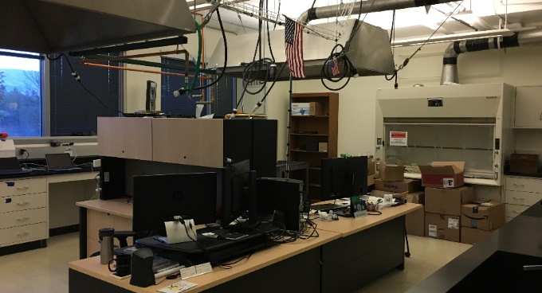The UI ***iDrone Lab*** (pictured left) at the UI’s Boise campus is the research laboratory for Dr. Jae Ryu. This 300-ft2 research lab can accommodate graduate students and visiting faculty and has facilities for secure storage and maintenance of UAS and related equipment. The UI iDrone Lab will be a secondary storage and maintenance facility for the proposed UAS Lidar system when it is being used for projects in southern Idaho.

**Computer**

The Drone Lab on UI’s main campus has 1 Linux (Ubuntu) and 1 Windows 10 computer workstations and 10TB of attached disk storage. The UI iDrone Lab on the Boise campus also contains 2 computer workstations (Windows 10) and 1 Linux server with 10TB of disk storage. In addition to the computer workstations and disk storage space in the Drone Lab and the iDrone Lab, each project PI maintains computer workstations and disk storage space for their projects.

All faculty, staff, and students using the UAS Lidar system also have access to the following UI facilities and resources for use in storing, processing, analyzing, and sharing Lidar data:

The *UI’s College of Natural Resources Geospatial Lab* is available to faculty for teaching and to undergraduate and graduate students for class or research projects requiring high-performance computers for GIS and remote sensing. The Geospatial Lab has 25 Dell workstations running Windows 10 that are replaced every 3 years to ensure the Lab always provides high-performance computers. Each computer has ESRI ArcGIS, ENVI, eCognition, R, Python, and other GIS and remote sensing software applications.

*Research Computing and Data Services (RCDS)* is the UI’s computational backbone for research. It provides investigators with access to reliable, state-of-the-art high-performance computing (HPC) and data storage infrastructure for use in analyzing and managing large volumes of multidisciplinary research data. RCDS provides the expertise and computational tools required for processing data across all stages of the scientific data lifecycle, including raw data acquisition, modeling and analysis, sharing, dissemination, and archival. RCDS technical staff include systems administrators, scientific programmers, web developers, and data managers that collaborate with researchers to transform scientific questions into meaningful results with broader impact.

The primary RCDS data center is a redesigned and renovated 1,400-ft2 facility in Room 124 in McClure Hall on the UI campus. Optical fiber and copper interconnections provide 1-25 Gb/s data transfer rates within the data center, which is connected to the multi-path 10Gb/s university backbone and from there to the Idaho Regional Optical Network (IRON) and Internet2. The McClure data center has a dedicated 80KVa UPS with three-phase power and four-forced air handlers attached to redundant university chilled water systems.

RCDS manages one large computer cluster for research and data analysis and modeling. Our main cluster provides over 2,500 processor cores and over 8 terabytes (TB) of system memory. The servers that comprise the cluster are interconnected with 40Gb/sec QDR (Quad Data Rate) Infiniband for inter-node communication and 1Gb/sec ethernet for management. Components include Dell M1000e blade enclosures with various blade servers, Dell rack servers, and various Supermicro servers. We have 16 cluster nodes with various NVIDIA GPU accelerators.

RCDS maintains a combination of high-performance data storage (290TB available) for active analysis projects, slower “commodity” storage for simple file storage and retrieval (1.9PB available), and long-term backup storage (898TB available, with 630TB located off site).

Finally, RCDS provides research data management infrastructure and services that enable UI investigators to store, catalog, disseminate, and archive their research data outputs. RCDS helps researchers write comprehensive Data Management Plans (DMPs) to include in their funding proposals. RCDS operates the UI’s official research data repository and is actively engaged with related national initiatives such as the Data Observation Network for Earth (DataONE) and the Earth Science Information Partners (ESIP). Through our involvement with DataONE, RCDS is part of a federation of similar repositories at a global scale, thereby increasing the exposure, resiliency, and discoverability of RCDS-published research data. We can also provision Digital Object Identifiers (DOIs) for datasets through our institutional DataCite membership.

**Office**

The UI provides adequate office space and related services to all project PIs at its main campus in Moscow (Karl, Keefe, Brooks, Gessler), at the Boise campus (Ryu, Winford), at the McCall Field Campus (Eitel), at the Parma Research and Extension Center (Walsh), or at the Coeur d’Alene campus (Kobziar).

**Other**

FAA Part 107 Remote Pilots

Project PIs Eitel, Karl, Kobziar, Li, Ryu, Walsh, and Winford have Federal Aviation Administration Part 107 Remote Pilot Certificates and extensive experience as Remote Pilot in Command for UAS missions.

UI Unmanned Aerial Systems Committee

The UI’s UAS Committee ensures safe and legal operation of UAS by University faculty, staff, students or third parties. The UAS Committee was established by the UI Vice President for Research and Economic Development to assess and approve all proposed UAS flights for compliance with state and federal laws, UI policy, risk, and ethical concerns. Project PI Karl is Chair of the UAS Committee, and PIs Li, Ryu and Eitel are standing committee members.

UI Field Research Stations

In addition to the above facilities, the UI maintains multiple research stations across Idaho where the Lidar system will be deployed. Projects listed in the proposal narrative will deploy the Lidar system at the following sites:

The ***UI Experimental Forest*** is a 10,300-acre actively managed working forest area northeast of Moscow, Idaho. The experimental forest facilitates basic and applied research in the context of productive working forestland, special management areas, and outdoor classrooms. Forest utilization research consistent with the university's land-grant mission and the guiding legislation of the Forest, Wildlife and Range Experiment Station under Idaho Code Title 38 forms the basis for core research in forest management that benefits the people of the state of Idaho. The UI Experimental Forest is managed by the UI’s College of Natural Resources.

The ***Harald Nokes Experimental Forest*** is a 1,650-acre montane forest research area in McCall, Idaho. The Herald Nokes Experimental Forest is co-managed by the UI’s College of Natural Resources and the Nokes family for forestry-related research and education.

The UI’s ***Rinker Rock Creek Ranch*** is a 10,400-acre working livestock ranch located in the Wood River Valley of central Idaho. The UI also holds 11,000 acres of Bureau of Land Management and state grazing allotments adjacent to the Ranch, which when combined with the fee title land, encompasses the entire Rock Creek watershed. This unique setting allows for watershed-scale research for sustainable rangeland management. Rinker Rock Creek Ranch is jointly managed by the UI’s College of Natural Resources and College of Agricultural and Life Sciences.

The UI’s ***Parma Research and Extension Center*** is a 200-acre farm near Parma, Idaho focused on research and extension programs in production, storage and related problems of vegetable, forages, cereals, hop, mint, fruit and seed crops. The Center includes 120 acres for row crop and hop research. And 30 acres devoted to tree fruit and small fruit research. In addition to office, laboratory, and classroom space, the Center also has 5,100 square feet of greenhouse space which is utilized year-round, a new vegetable and fruit storage facility for post-harvest management research, and 540 square feet of growth chamber rooms for entomology research projects.

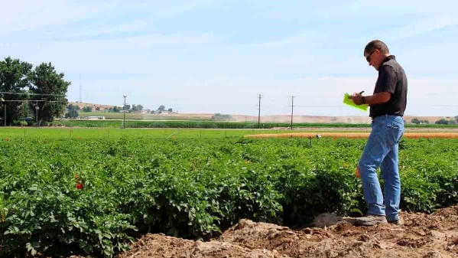The UI’s ***Parker Farm at the UI Palouse Research, Extension and Education Center*** in Moscow, Idaho is a 172-acre farm used for research on pest management, crop production, and plant breeding and genetics. The Parker Farm hosts both short (one growing season or less) and long-term (several growing seasons) research. Parker Farm also provides equipment (field-size and plot-size tilling, seeding, spraying and harvesting equipment for small grain, legume, Brassicaceae and many other crops) and personnel for research conducted by UI faculty on private lands in northern Idaho and eastern Washington.